Question 4: Using MVC model to implement three pages as follows:
- Write a controller servlet that can navigate to views in some cases as follows:
- If session object does not contain any bean of AccountBean or bean has empty user name, navigate to “Login.jsp”
- Retrieve submission data from “Login.jsp” and initialize a bean object from class AccountBean with user name as parameter of constructor.
- Check position of login user
  - If position of user is “Manager”, navigate to “WelcomeManager.jsp” using object of class RequestDispatcher.
  - If position of user is “Officer”, navigate to “WelcomeOfficer.jsp”, using object of class RequestDispatcher.
- Write a page “Login.jsp” and submit form data to controller as follows

Depend on position of user name in Account.xml, write pages as following questions
- Write a page “WelcomeManager.jsp” and retrieve bean object in session object and display information of user as follows:
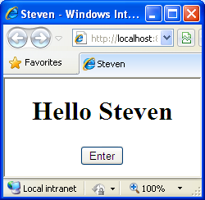
- Write a page “WelcomeOfficer.jsp” and retrieve bean object in session object and display information of user in the same way of manager page.

